Module-3
1.Guest Type Analysis
Columns Added in customer table:
Customercluster:=IF(SUMIFS(tbl_bookings!$G:$G,tbl_bookings!$E:$E,$A5822)>=PERCENTILE.INC(SUMIFS(tbl_bookings!$G:$G,tbl_bookings!$E:$E,Customer!$A$2:Customer!$A$5905),0.8),"High Spender",IF(COUNTIFS(tbl_bookings!$E:$E,$A5822)=1,"First-timer","Loyal"))
Guest type: =IF(J2="Honeymoon","Couple",IF(J2="Family Vacation","Family",IF(J2="Business Trip","Single",IF(J2="Conference","Single",IF(J2="Tourism","Couple",IF(J2="Medical Visit","Single",IF(J2="Wedding","Family",IF(J2="Education Visit","Single",IF(J2="Sports Event","Family",IF(J2="Transit Stay","Single","Couple"))))))))))
Age Group:=IF(D2<13,"Child",IF(D2<18,"Teen",IF(D2<60,"Adult","Senior")))
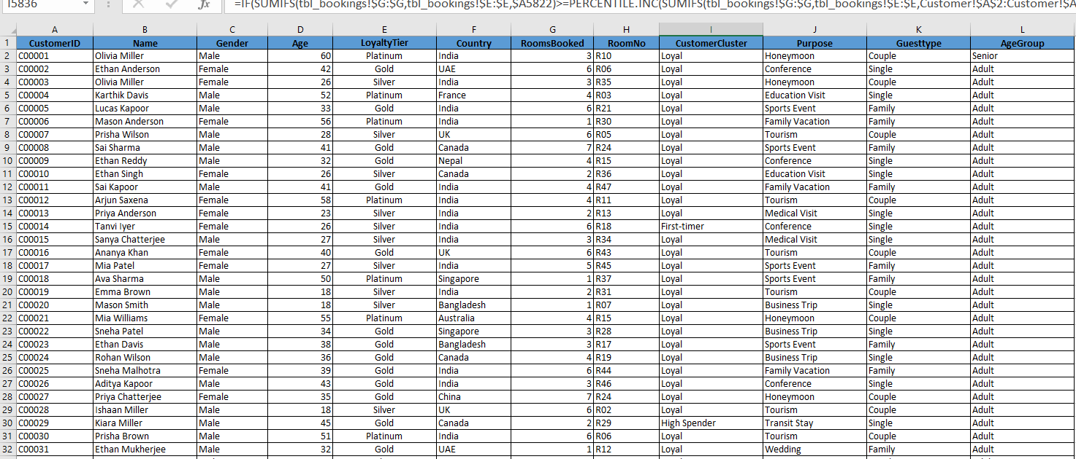
2.Creating guest table
Tbl_Guests =
SUMMARIZE(
tbl_bookings,
tbl_bookings[CustomerID],
"FirstStay", MIN(tbl_bookings[CheckIn]),
"LastStay", MAX(tbl_bookings[CheckOut]),
"GuestCount", COUNT(tbl_bookings[BookingID]),
"SpendScore", SUM(tbl_bookings[TotalAmount])
)
Frequence Score:FrequencyScore = VAR F = CALCULATE(COUNTROWS(tbl_bookings), FILTER(tbl_bookings, tbl_bookings[CustomerID] = Tbl_Guests[CustomerID])) RETURN F
Recency Score:Recency = TODAY() - Tbl_Guests[LastStay]

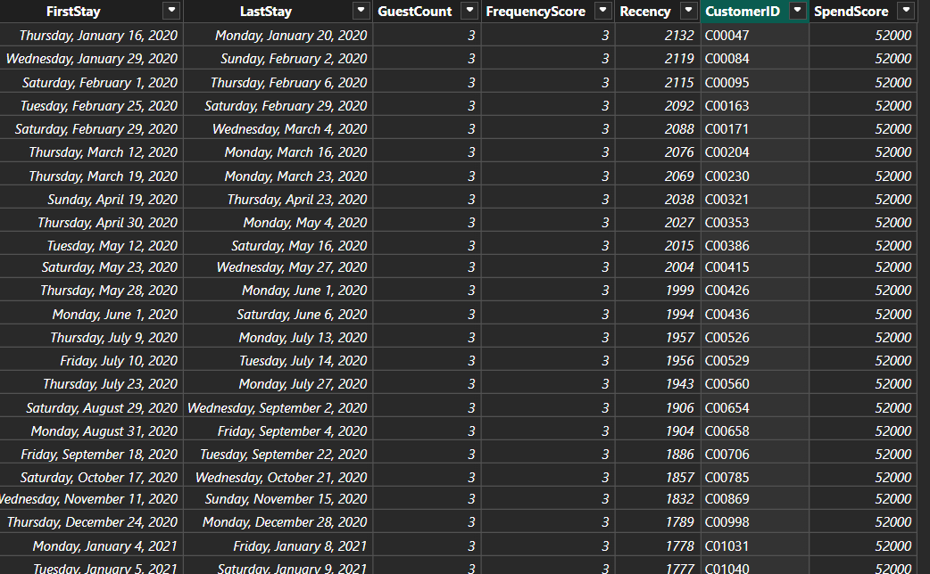
3.Visualisations:
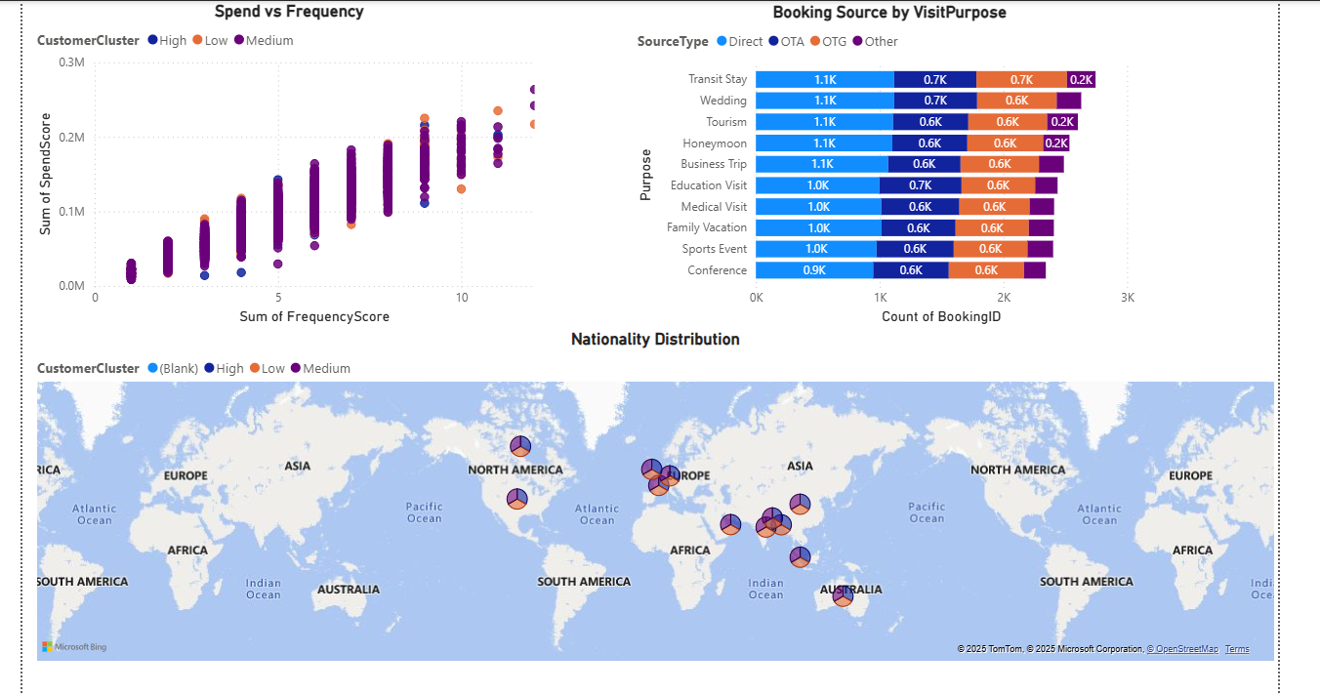
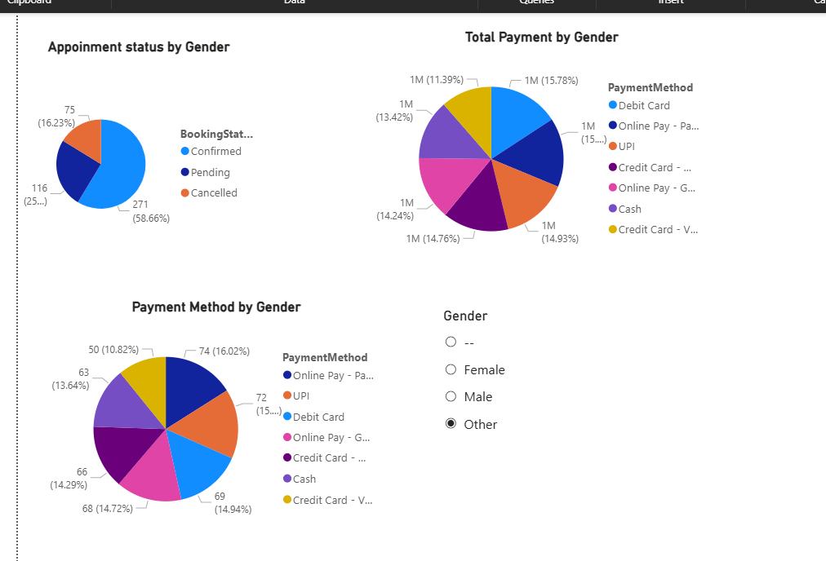

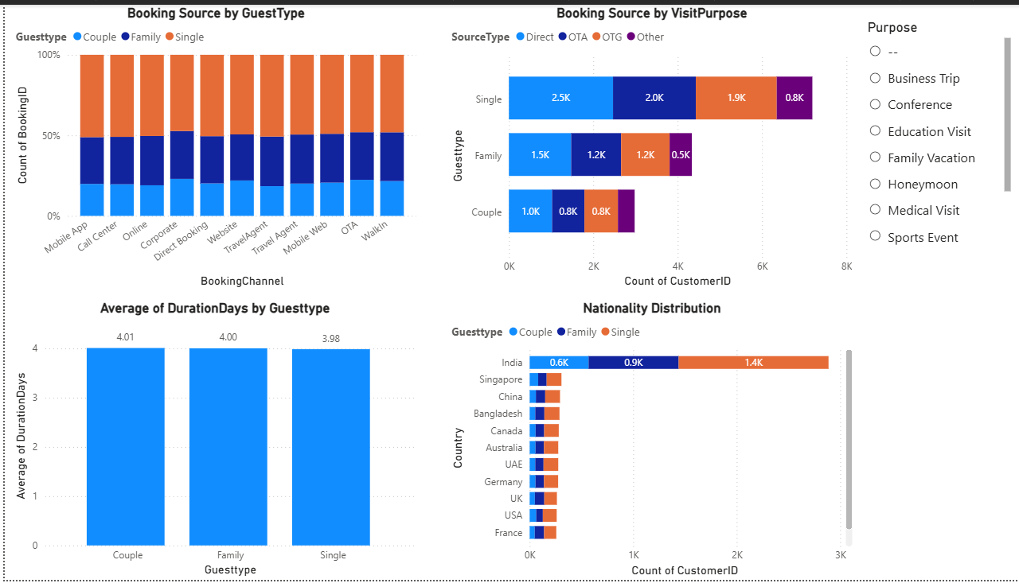

6.Dashboards
A.Basic Analysis
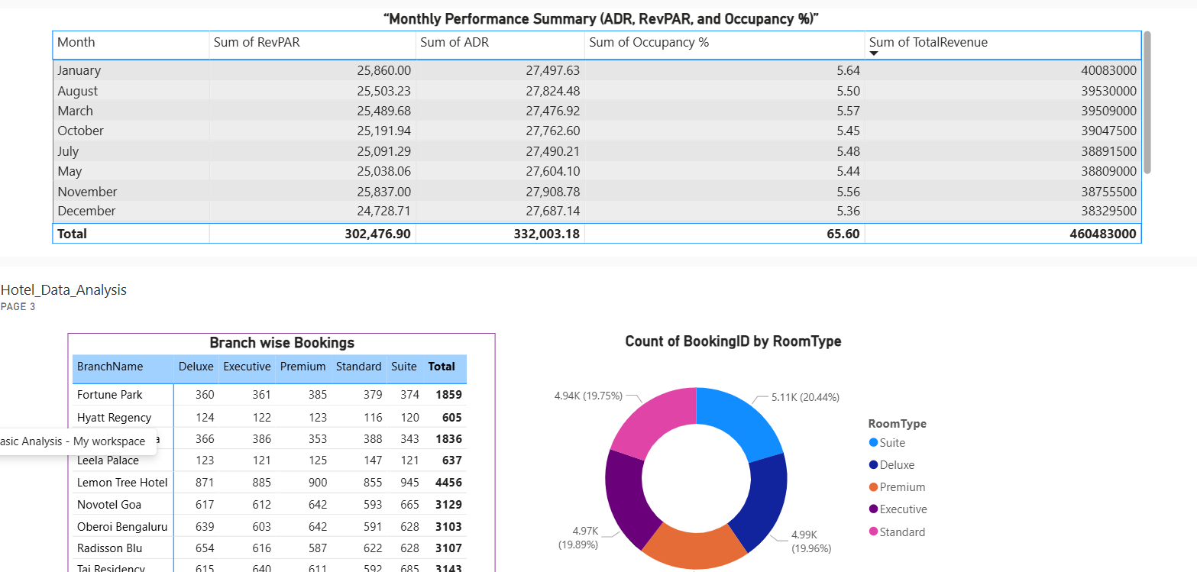
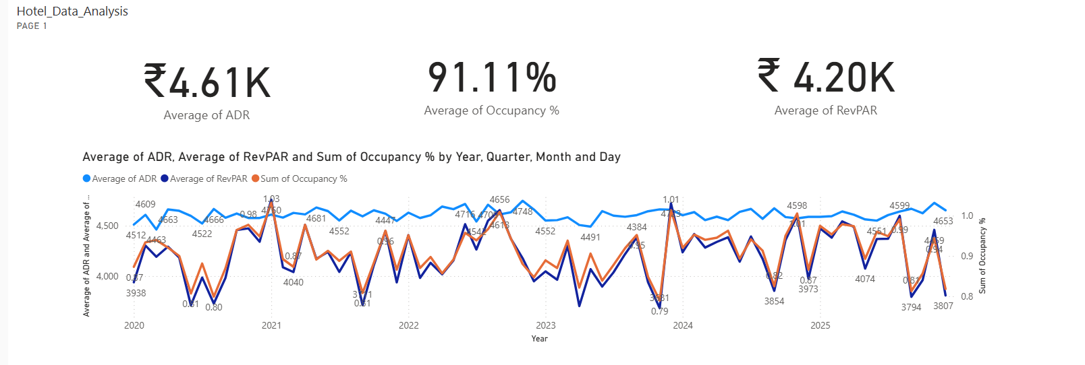

B.Performance Analysis
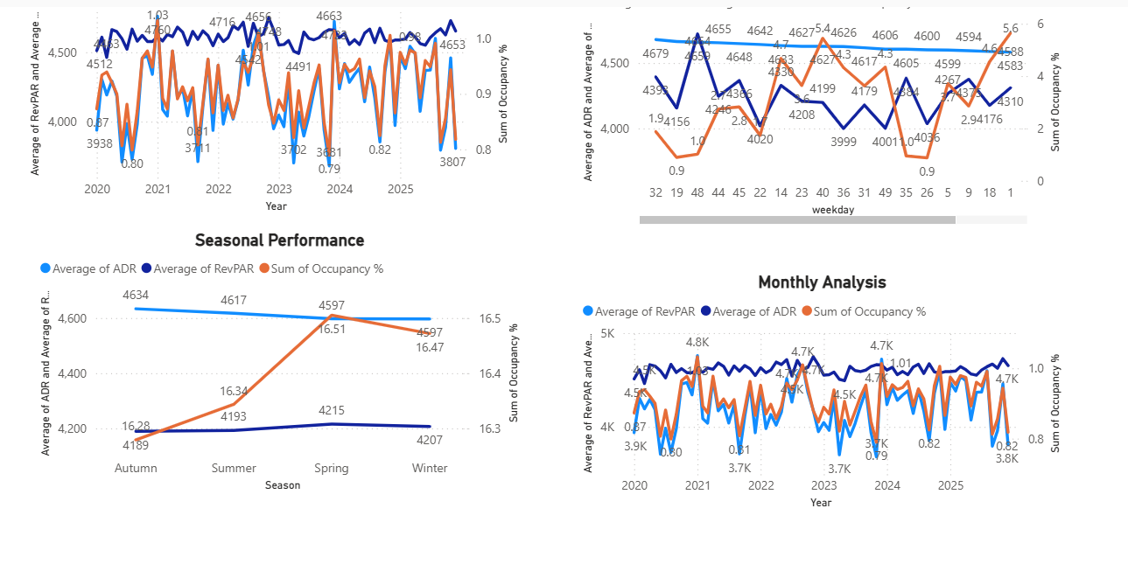
C.Guest Analysis